Ideation Phase
Brainstorm & Idea Prioritization Template

Date | 14 July 2026
Team ID
Project Name | CAB BOOKING
Maximum Marks | 4 Marks

Brainstorm & Idea Prioritization Template:
Brainstorming for the Cab Booking System encouraged the team to generate innovative ideas to solve common transportation challenges such as ride booking, driver availability, fare estimation, and passenger safety. Through collaboration and idea prioritization, the team selected the most practical and valuable features to develop a reliable, secure, and user-friendly Ride Ready platform.
Reference: https://www.mural.co/templates/brainstorm-and-idea-prioritization
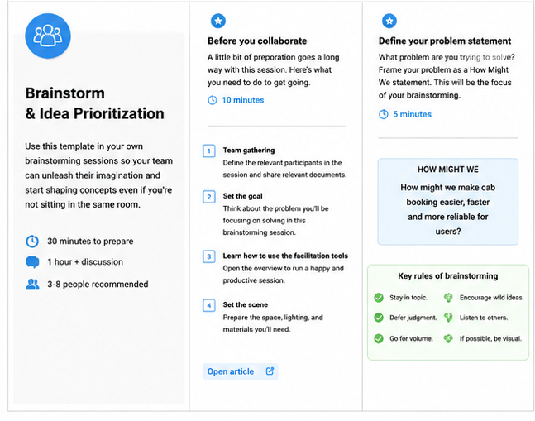
Step-1: Team Gathering, Collaboration and Select the Problem Statement

Step-2: Brainstorm, Idea Listing and Grouping
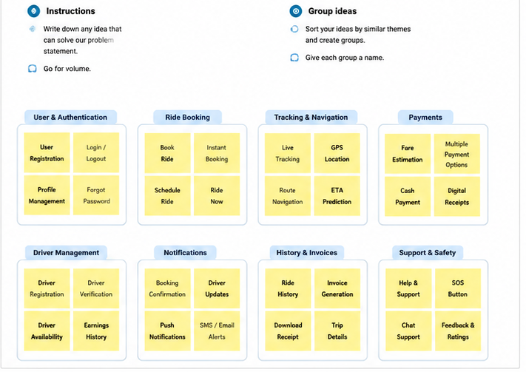

Step-3: Idea Prioritization
